Date |  | 9/4/2025 |  |  |  | Date of Report issuance |  |  | 9/4/2025
Time |  | 2133 hrs |  |  |  | Weather |  |  | Clear
Location/Area |  | Stock pile E & Lay down area – Zone 3 |  |  |  | VMECC Personnel Information
Type of  Emergency /  Incident |  |  | FIRE |  |  | SC | Ridzal Aziz
 |  |  | RESCUE |  |  | ASC | Sofjowardi
 |  |  | HAZMAT / OIL SPILL |  |  | TRT 1 | Ikhwan
 |  | X | SPECIAL ASSISSTANCE/SERVICES |  |  | TRT 2 | Safwan Sani
Details of Emergency |  | Wild Boar sighted at Stockpile E  ERP Annex 24 (Wildlife encounter) |  |  |  | TRT 3 | Rosli.M (FTO)
 |  |  |  |  |  | TRT 4 | Irfan
SUMMARY OF EMERGENCY/ INCIDENT
VMECC received report from CCR via walkie talkie reporting a Wild Boar has sighted at Stockpile E. The team was deployed to the location for assist and after arrived, there were one Wild Boar at location and run away onto bush near the natural pond. No activity that area while that happen. Team met YL to inform the situation and please to reported any sign of wild boar should be informed immediately to VMECC. Team RTB.
CHRONOLOGY OF EVENT
Time | Event/ Action
2133 | VMECC received call via Walkie Talkie from CCR reporting that there were Wild Boar sighted at Stockpile E
2135 | Team proceeds to location
2140 | Team arrived location and reporting one Wild Boar sighted
2141 | Team reported, Wild Boar was run away onto bush near natural pond
2144 | Team met YL to inform the situation.
2150 | Team RTB

STRENGTHS
- Response time in line with 2025 KPI (1.2 Adherence Response Time) targets.
- Available and operational resources: ER Equipment and response vehicles & PPE
- VMECC TRTM with Wildlife management.
RESOURCES, EQUIPMENT & CONSUMABLES MOBILISED
- Rapid Intervention Vehicle (RIV)
- PPE
- Walkie Talkie
IMPROVEMENT OPPORTUNITIES
Wild boar has several times sighted and reported at stockpile area. Team believed there is only one wild boar in that area. The Wild Boar should be captured for safety reason
PHOTOGRAPH
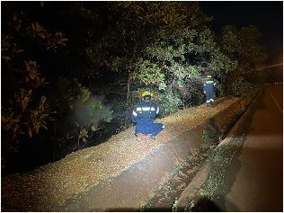
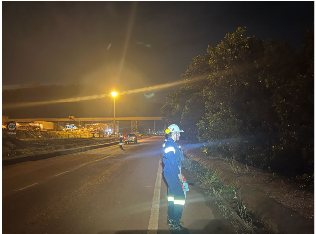
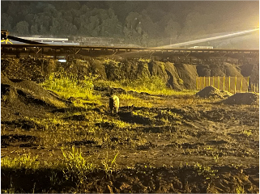
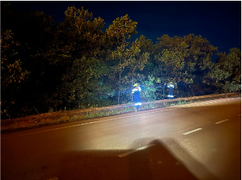
Prepared by: | Sofjowardi  ASC Bravo VMECC   |  |  | Reviewed by: | Ridzal Aziz  SC, VMECC   |  |  | Vale Review by:
Date: | 9/4/2025 |  |  | Date: | 10/4/2025 |  |  | Date:

